**REST - Country Web Service**

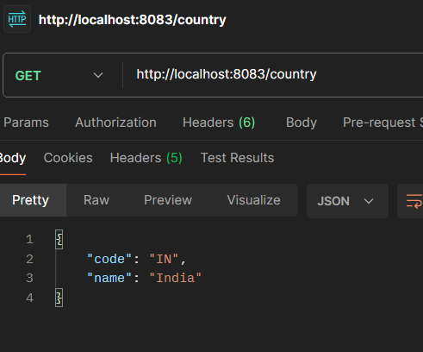

**SME to explain the following aspects:**

* **What happens in the controller method?**

ApplicationContext loads country.xml

Bean with ID "in" is fetched

Bean is returned → Spring automatically converts it to JSON using Jackson

* **How the bean is converted into JSON reponse?**

In Spring Boot, beans are automatically converted to JSON using Jackson. When a Country object is returned from a @RestController, Spring uses Jackson to serialize it into JSON and sends it as the HTTP response with Content-Type: application/json.

* **In network tab of developer tools show the HTTP header details received**

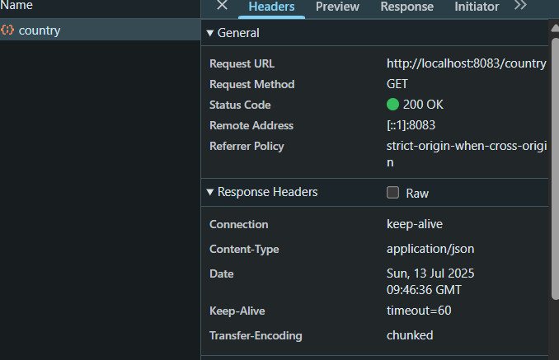

* **In postman click on "Headers" tab to view the HTTP header details received**

